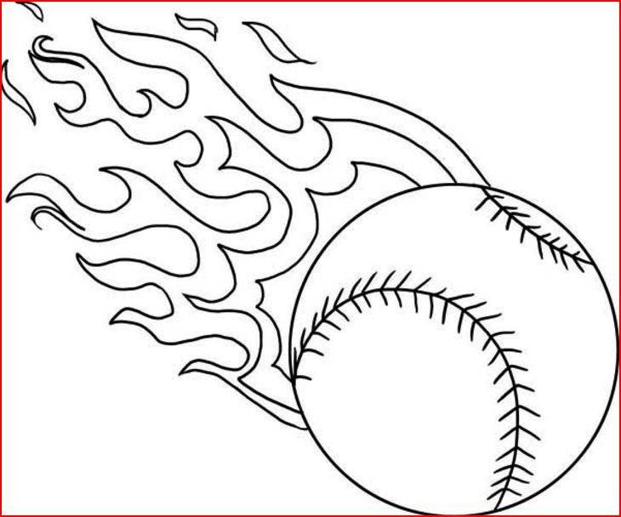
2019 AUTHORIZATION FOR MEDICAL CARE OF A MINOR

I _____________________, THE UNDERSIGNED PARENT/GUARDIAN OF ________________________, DO HEREBY AUTHORIZE THE GREEN RIVER GIRLS SOFTBALL LEAGUE REPRESENTATIVE:
To consent to any x-ray examination, medical, surgical or dental diagnosis or treatment and hospital care to be rendered to the above named minor under general or special supervision and upon the advice of a physician, surgeon or dentist licensed under the laws of the State of Wyoming and Utah. In giving this consent I recognize and understand that in situations where the above named minor requires immediate medical attention or hospital care it may not be possible to contact me, and that in such situations I will not be able to knowledgeably evaluate and choose among the available treatments or procedures, if any, or to evaluate the risks attendant to foregoing all treatment; in such situations, I authorize a physician, surgeon, or dentist to exercise his professional judgment and assess the risks incident to and choose the necessary treatment from any available alternatives and to render such care and perform such treatment as they in their professional judgment determines to be necessary for the health and safety of the above named minor.

DATE:_____________________________
SIGNATURE PARENT/GUARDIAN:________________________________________
PHONE: ________________________
ADDRESS: ______________________________________________
HEALTH/TREATMENT INFORMATION:
MINOR’S DATE OF BIRTH: ____________________________
ANY ALLERGIES: _______________________________________________________
DOCTOR’S NAME AND ADDRESS: __________________________________________
DENTIST’S NAME AND ADDRESS: __________________________________________
IS MINOR TAKING MEDICATIONS: __________________________________________
IF YES, PLEASE STATE NAME OF MEDICATION: _________________________________
MINOR’S MEDICAL HISTORY: ___________________________________________
_______________________________________________________________________
DATE OF LAST TETANUS SHOT: _______________
INSURANCE CO.: ____________________________________
POLICY NUMBER: ___________________________________
RESPONSIBLE PARTY FOR INSURANCE: ________________________________

